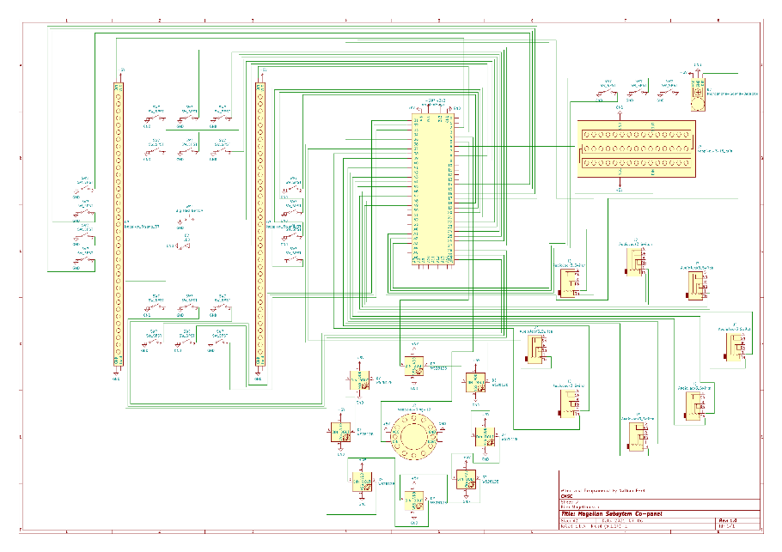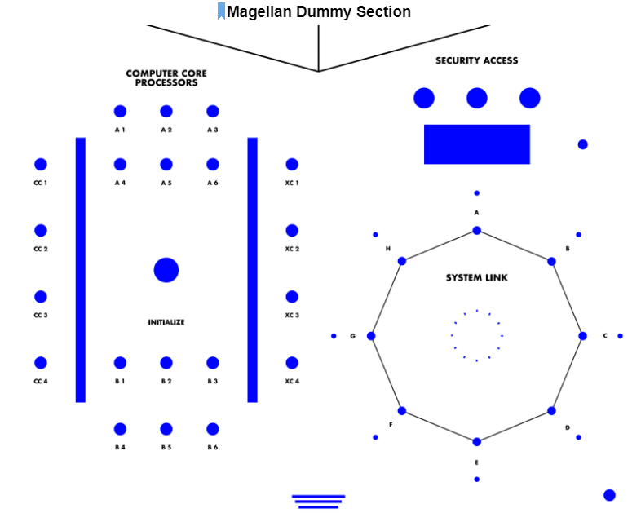Magellan Subsystem Wiring

* Light Strips
* Jack Wheel
* Oscilloscope

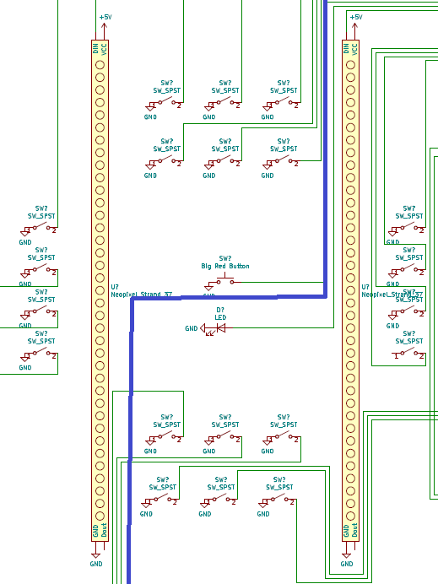Light Strips

The light strips are what I consider to be the bread and butter of this panel, these are what takes up most of the space on the panel and are much of the visual effects on this panel.

The wiring of this is mirrored in a way think of it like this, it is cut kind of down the middle, but the top goes to the left and the bottom to the right (shown on the right). Do note that the Big Red Button Affects both sides though.

Pins

1. 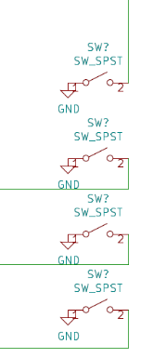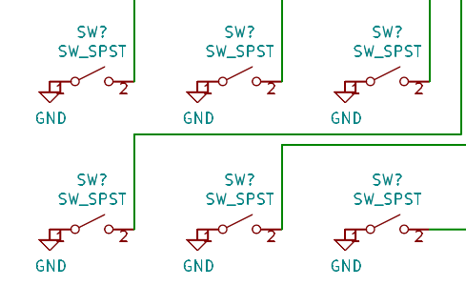6 Middle Switches - Remember one side goes to ground and the other pin to the Arduino.

|  |  |  |
| --- | --- | --- |
| **Switch placement** | **Side 1 Arduino Pin** | **Side 2 Arduino Pin** |
| Top left | 22 | 28 |
| Top middle | 23 | 29 |
| Top right | 24 | 30 |
| Bottom left | 25 | 31 |
| Bottom middle | 26 | 32 |
| Bottom right | 27 | 33 |

1. 4 Side Switches

|  |  |  |
| --- | --- | --- |
| **Switch placement** | **Side 1 Arduino Pin** | **Side 2 Arduino Pin** |
| Top | 14 | 18 |
| Middle Top | 15 | 19 |
| Middle Bottom | 16 | 20 |
| Bottom | 17 | 21 |

1. Bars- these are the bars of the neo pixels, one of them shows all lights from the switches in a track, like a conveyor belt, the other one splats them down randomly.

|  |  |
| --- | --- |
| **Bar 1 Pin** | 2 |
| **Bar 2 Pin** | 3 |

1. 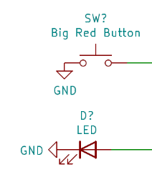THE BIG RED BUTTON, super straightforward, one side to ground, the other to pin 9, for the light on it, one side goes to pin 8 and the ground side of the lead goes to ground.

Jack Wheel

This is where we get to have some fun, everybody loves it when you get to plug wires and lights start to light up, makes you feel like you are fixing something! That is what this next part of the panel does, and the wiring is straight forward

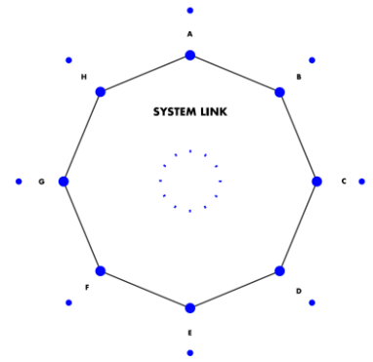First, we have the lights, we have a middle wheel of 12 neo pixels and an outer ring of 8 lights, one next to each jack.

|  |  |
| --- | --- |
| **Neo Pixel** | **DIN Pin on Arduino** |
| Middle 12 Ring | 4 |
| Outer 8 Ring | 5 |

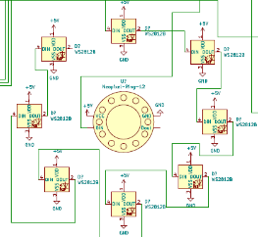

Secondly, we have the jacks, this is where it gets a little more, “Fun”.

|  |  |  |
| --- | --- | --- |
| **Jack** | **Detect Pin Arduino** | **Plug Pin Arduino** |
| A | 48 | 49 |
| B | 46 | 47 |
| C | 44 | 45 |
| D | 42 | 43 |
| E | 40 | 41 |
| F | 38 | 39 |
| G | 36 | 37 |
| H | 34 | 35 |

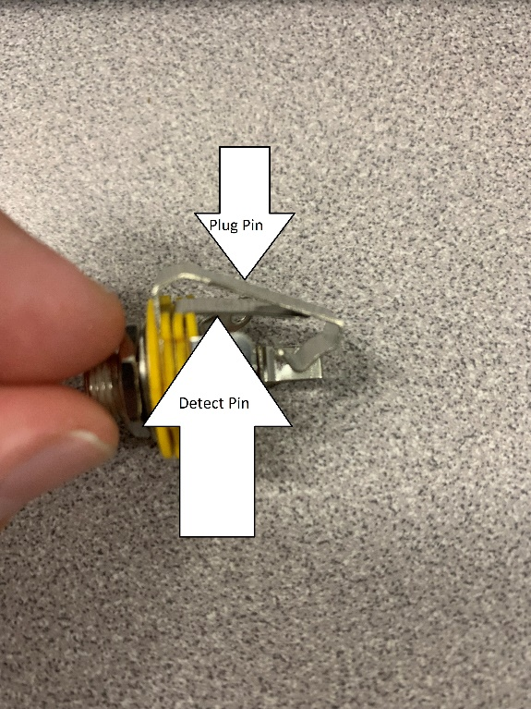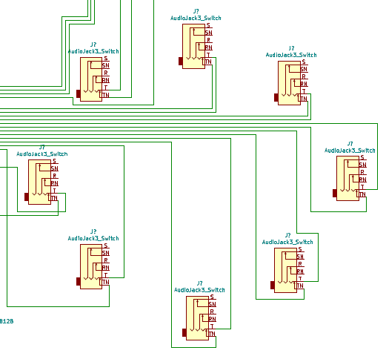

Oscilloscope

This is what I would consider the simplest of all 3 major parts of this panel to wire, just a few wires.

1. 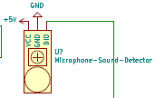Microphone – we used a weird microphone that wasn’t actually a microphone, it just gave a signal if it heard sound over a certain threshold, and wasn’t verry reliable, so it may be worth it if you are re constructing to use a different one, but this one is simple and won’t require modification to the code, you apply 5v, GND and plug its data out to pin A0 on the Arduino.
2. 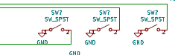Switches – these are just some round rocker SPST switches that we used, as usual, one side to ground the others to the arduino.

|  |  |
| --- | --- |
| **Switch** | **Arduino Pin** |
| Left | A1 |
| Middle | A2 |
| Right | A3 |

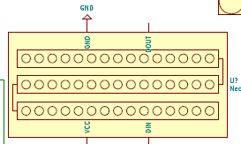

1. Neo Pixels – This is a grid that was handmade, we just used 3 cut segments of strands, each 15 long, for a total of 45 lights in a 3x15 array, this is hooked to 5v, GND and Pin 6 on the Arduino.